TITLE OF THE ARTICLE Times New Roman, 16pt, Bold, Center)

Name, Surname, Academic degree, Name of University or Institution, Mail, City, Country, if there are co-authors, every author should be on a new row with the same formatting (Times New Roman, 14pt, bold, Center)

Scientific supervisor (Times New Roman, 12pt, Right)
Scientific degree
Name of University or Institution

Batumi
2025

Abstract: (Times New Roman, 12 pt, Justify, 200 – 300 words)
Keywords: (Times New Roman,12 pt, min 3, max 5)

Introduction
Introduce the research topic, main objectives, scope and existing hypotheses. A review and understanding of relevant literature should also be presented in this section (Sylfaen,12 pt, Justify).

Title of the first paragraph (if applicable)
(Times New Roman,12 pt, Justify).
Figure 1. Title of the figure (Times New Roman, 12 pt, center)
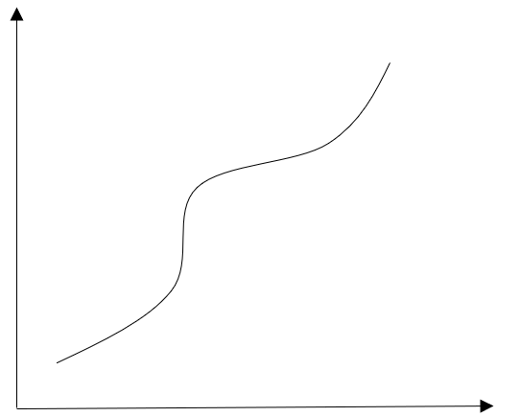
Source: Source of the figure (Times New Roman, 12 pt, center)
A figure should be centered. Data in the figure should be formatted with Times New Roman font, 12pt.

Title of the second paragraph (if applicable)
(Times New Roman,12 pt, Justify).
Table 1. Title of the Table (Times New Roman, 12 pt, center)
Name | Year | Quantity
This is an example | This is an example | This is an example
Source: Source of the Table (Times New Roman, 12 pt, center)
A table should be centered. Data in the table should be formatted with Times New Roman font, 12 pt.
bulleted/numbered lists:
- A
- B
- C
- D

Title of the third paragraph (if applicable)
(Times New Roman,12 pt, Justify).
Use the Equation command to write formulas (insert > equation)

Results and Conclusions
Discuss the importance of the work, present the possibilities of its practical and theoretical application. (Times New Roman,12 pt, Justify)

References
References are formatted according to the international bibliographical standard, APA-style. (Times New Roman,12 pt, Justify)

